FONT

1. FONT

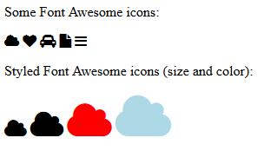

Keterangan:

**Some font Awesome Icons :** untuk menampilkan icons pada suatu website seperti gambar.

**Styled Font Awesome Icons : untuk menampilkan** jenis icon,ukuran dan warna dalam suatu website seperti pada web screen diatas

**SOURCE CODE**

<html>

<head>

<title>Font Awesome Icons</title>

<meta name="viewport" content="width=device-width, initial-scale=1">

<link rel="stylesheet" href="https://cdnjs.cloudflare.com/ajax/libs/font-awesome/4.7.0/css/font-awesome.min.css">

</head>

<body>

<p>Some Font Awesome icons:</p>

<i class="fa fa-cloud"></i>

<i class="fa fa-heart"></i>

<i class="fa fa-car"></i>

<i class="fa fa-file"></i>

<i class="fa fa-bars"></i>

<p>Styled Font Awesome icons (size and color):</p>

<i class="fa fa-cloud" style="font-size:24px;"></i>

<i class="fa fa-cloud" style="font-size:36px;"></i>

<i class="fa fa-cloud" style="font-size:48px;color:red;"></i>

<i class="fa fa-cloud" style="font-size:60px;color:lightblue;"></i>

</body>

</html>